lJGF D}<I[
5ZL1FFG]\ GFD o v _________
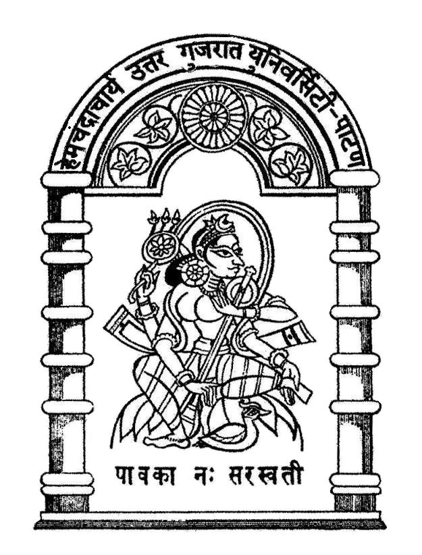
C[DR\ãFRFI" p¿Z U]HZFT I]lGJL;"8L45F86P
5NJL 5|DF65+ D[/JJF DF8[G]\ VZHL5+S

5|lT4
S], ;lRJzL4
C[DR\ãFRFI" p¿Z U]HZFT I]lGJL;"8L4
5F86 v #($Z&5

zLDFG4
DFZ[ _____________________ 5ZL1FFG]\ 5NJL 5|DF65+ D[/JJF DF8[ lGIT OL ~FP Z__qv ZMS0F H[GM 5CM[R G\AZ___________ TFP ____________ q 0LP 0LP G\P TFP YL HDF SZFJ]\ K]\P
v l0%,MDF\ .G OFD";L T[DH A[R,Z VMO OFD";LGF lJnFYL"VM DF8[ *5_ S,FSGL 5|[S8LS, 8=[GL\UG]\ 5|DF65+ ZH} SZ[, K[P
v CMDLIM5[YLS 5ZL1FF 5F; SIF" 5KL .g8G"XL5 5}6" SIF" ;AAG]\ ;8L"lOS[8 ZH] SZ[, K[P
:Y/ ov VF5GM lJ`JF;]
TFZLB o
slJnFYL"GL VFBL ;CLf
sGLR[GL lJUTM VZHNFZ[ DM8F VG[ :JrK V1FZMDF\ EZJLf
V8S GFD l5TF q 5lTG]\ GFD
GFD o
sV\U|[HL S[5L8, V1FZMDF\ DFS";L8 D]HAf
GFD o
sU]HZFTLDF\f
SFIDL ZC[9F6G]\ ;ZGFD]\ o 5LG SM0 G\P
OMG G\P DMAF., G\P
5ZL1FFG]\ GFD 5F; SIF"GM DlCGM VG[ JQF"o
5|F%T SZ[, JU" A[9S G\AZ o
D]bI lJQFI q lJQFIM
SM,[HG]\ GFD o
HFlT s 5]~QF q :+L f VFWFZ SF0" G\AZ ov____________________
5NJL 5|DF65+ D[/JJF DF8[G]\ VZHNFZG]\ ;ZGFD]\ o
s:5Q8 V1FZ[ A\G[ AFH] ,BJ]\f
VZHNFZG]\ GFD o |  | VZHNFZG]\ GFD o
X[ZL o |  | X[ZL o
UFD o |  | UFD o
TF,]SM o | HL<,M o | TF,]SM o | HL<,M o
5LG SM0 G\Po | DMPG\Po | 5LG SM0 G\Po | DMPG\Po

